Kyle Kasmiersky
Aero 4630
Professor Luo
Homework 5
- Consider the following mass-spring system discussed in class.
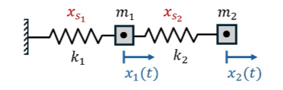
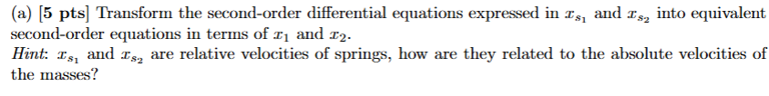
$${\dot{x}}_{s1}=v_{1};{\dot{x}}_{s2}=v_{2}-v_{1}$$
$${\ddot{x}}_{s1}=-\frac{k_{1}}{m_{1}}x_{s1}+\frac{k_{2}}{m_{1}}x_{s2};{\ddot{x}}_{s2}=-\frac{k_{1}}{m_{1}}x_{s1}-\left(\frac{k_{2}}{m_{1}}+\frac{k_{2}}{m_{2}}\right)x_{s2}$$
Plugging in
$$a_{1}=-\frac{k_{1}}{m_{1}}x_{1}+\frac{k_{2}}{m_{1}}\left(x_{2}-x_{1}\right);a_{2}=-\frac{k_{1}}{m_{1}}x_{1}-\left(\frac{k_{2}}{m_{1}}+\frac{k_{2}}{m_{2}}\right)\left(x_{2}-x_{1}\right)$$
Simplify
$$a_{1}=-\left(\frac{k_{1}}{m_{1}}+\frac{k_{2}}{m_{1}}\right)x_{1}+\frac{k_{2}}{m_{1}}x_{2}$$
$$a_{2}=-\frac{k_{1}}{m_{1}}x_{1}-\left(\frac{k_{2}}{m_{1}}x_{2}+\frac{k_{2}}{m_{2}}x_{2}-\frac{k_{2}}{m_{1}}x_{1}-\frac{k_{2}}{m_{2}}x_{1}\right)$$
$$a_{2}=\left(-\frac{k_{1}}{m_{1}}+\frac{k_{2}}{m_{1}}+\frac{k_{2}}{m_{2}}\right)x_{1}-\left(\frac{k_{2}}{m_{1}}+\frac{k_{2}}{m_{2}}\right)x_{2}$$

$$a_{1}=-\left(\frac{1}{10}\right)x_{1}+\frac{1}{20}x_{2}$$
$$a_{2}=\frac{20}{20}x_{1}-\left(\frac{21}{20}\right)x_{2}$$
$$\left[\begin{aligned}a_{1} \\ a_{2}\end{aligned}\right]=\left[\begin{matrix}-1/10 & 1/20 \\ 1 & -21/20\end{matrix}\right]\left[\begin{aligned}x_{1} \\ x_{2}\end{aligned}\right]$$
Let $\underline{x}=\left[\begin{aligned}x_{01} \\ x_{02}\end{aligned}\right]e^{αt}$
$$\left[\begin{aligned}x_{01} \\ x_{02}\end{aligned}\right]α^{2}=\left[\begin{matrix}-\frac{1}{10} & \frac{1}{20} \\ 1 & -\frac{21}{20}\end{matrix}\right]\left[\begin{aligned}x_{01} \\ x_{02}\end{aligned}\right]$$
$$\det\left(A-λI\right)=0$$
$$\left|\begin{matrix}-\frac{1}{10}-λ & \frac{1}{20} \\ 1 & -\frac{21}{20}-λ\end{matrix}\right|=0$$
$$\left(-\frac{1}{10}-λ\right)\left(-\frac{21}{20}-λ\right)-\frac{1}{20}=0$$
$$λ^{2}+\frac{23}{20}λ+\frac{21}{200}-\frac{10}{200}=0$$

- asdf

